**INT 219 – FRONT END WEB**

**DEVELPOMENT**

Faculty – Dr. Baljit Singh Saini

Continuous Assessment Project

Name - Mayank Section – KE083

Roll number – RKE083A29

Question Statement

**Table of Context**

|  |  |  |
| --- | --- | --- |
| **S n.o** | **Title** | **Page** |
| 1 | Title Page |  |
| 2 | Question Statement |  |
| 3 | Language Used |  |
| 4 | Landing Page |  |
| 5 | Layout of grids |  |
| 6 | How To Play |  |
| 7 | Result and Rating |  |
| 8 | Harder Levels |  |
| 9 | Repository |  |
|  |  |  |

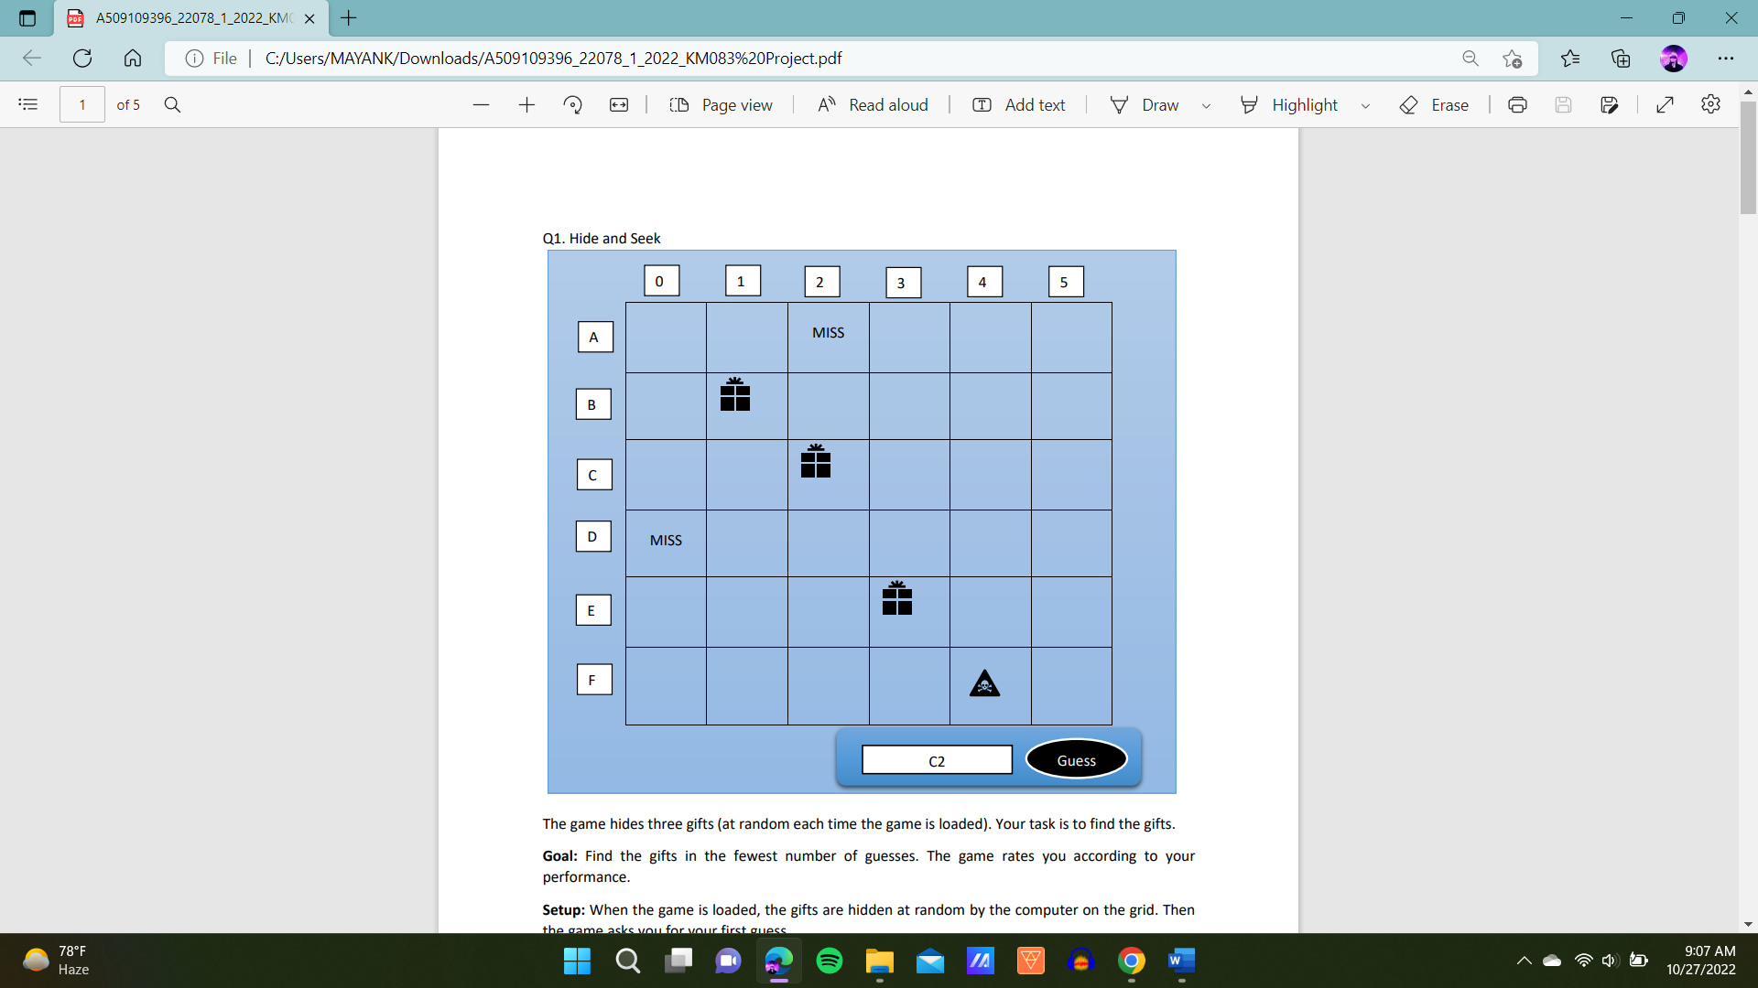

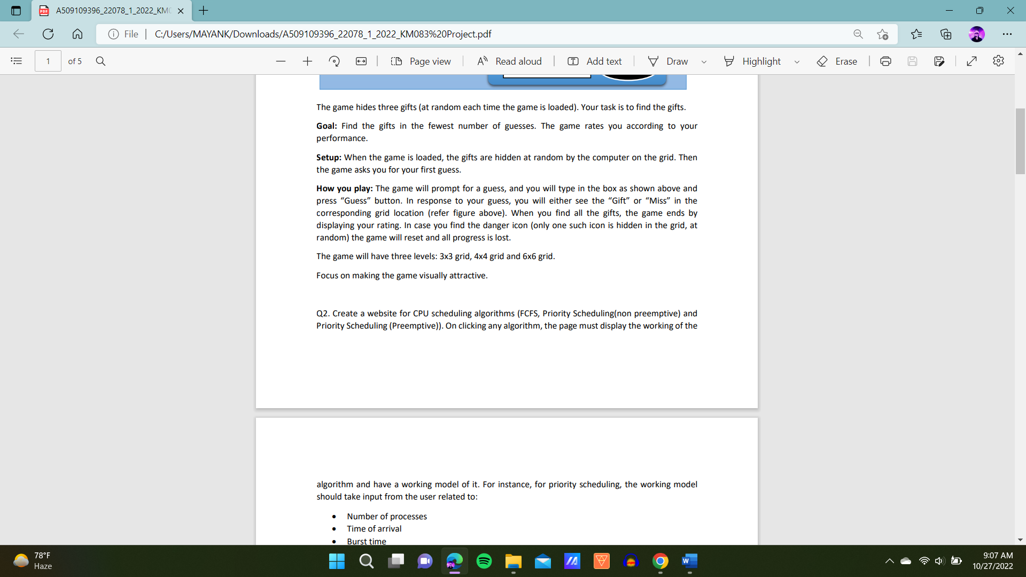

Language Used

1.HTML

2. CSS

3.JavaScript

Landing Page(Main.html)

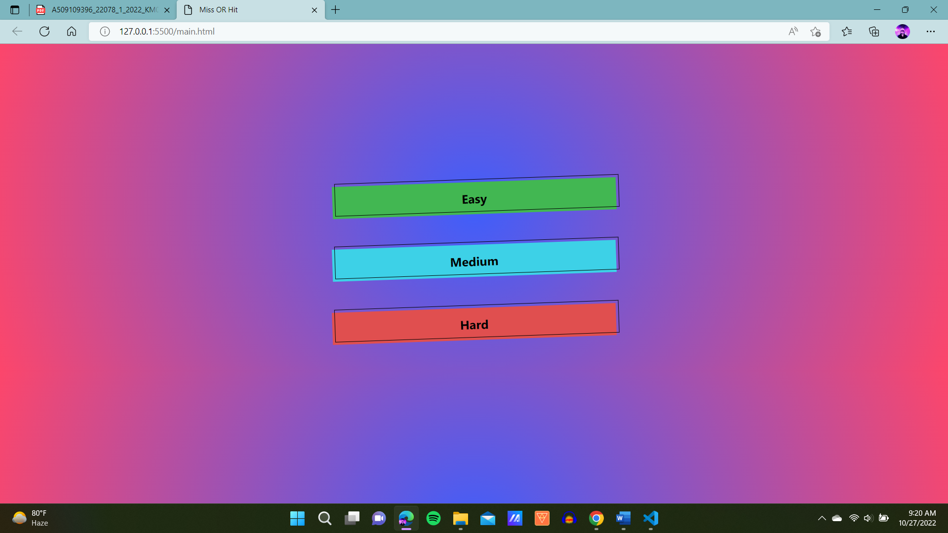

A landing page to navigate between the levels

[Easy (3X3)]

[Medium(4X4)]

[Hard(6X6)]

Layouts Of The Game

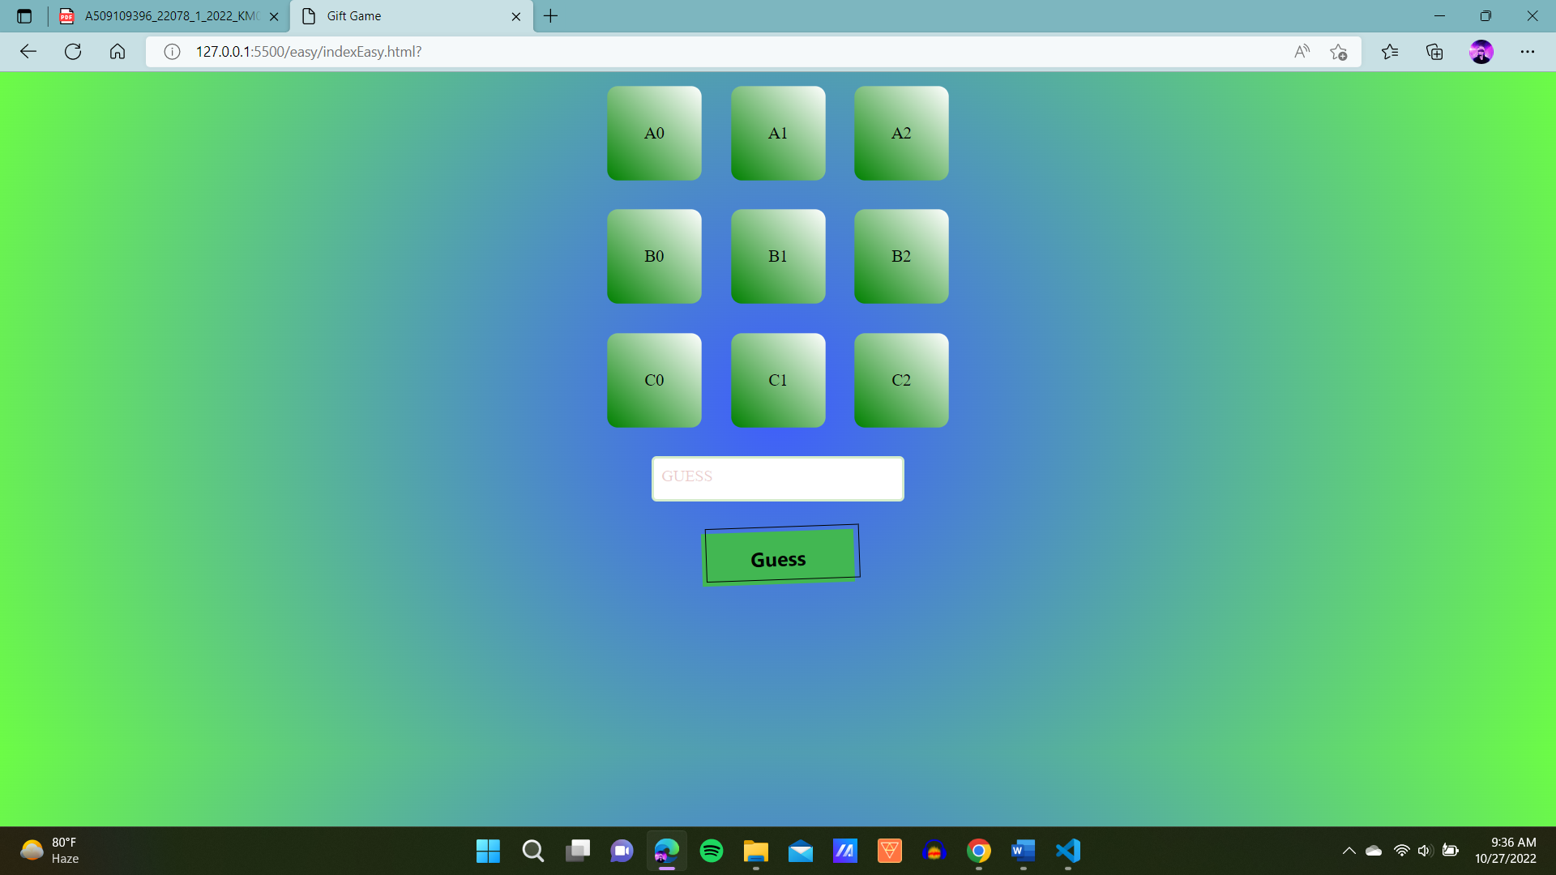

Each level Contains

1. Grid - Gift ,Miss and Danger Hidden

2. Input Box - To Guess the grid address

3. ‘GUESS’ Button – Click this button to make a guess

How to play

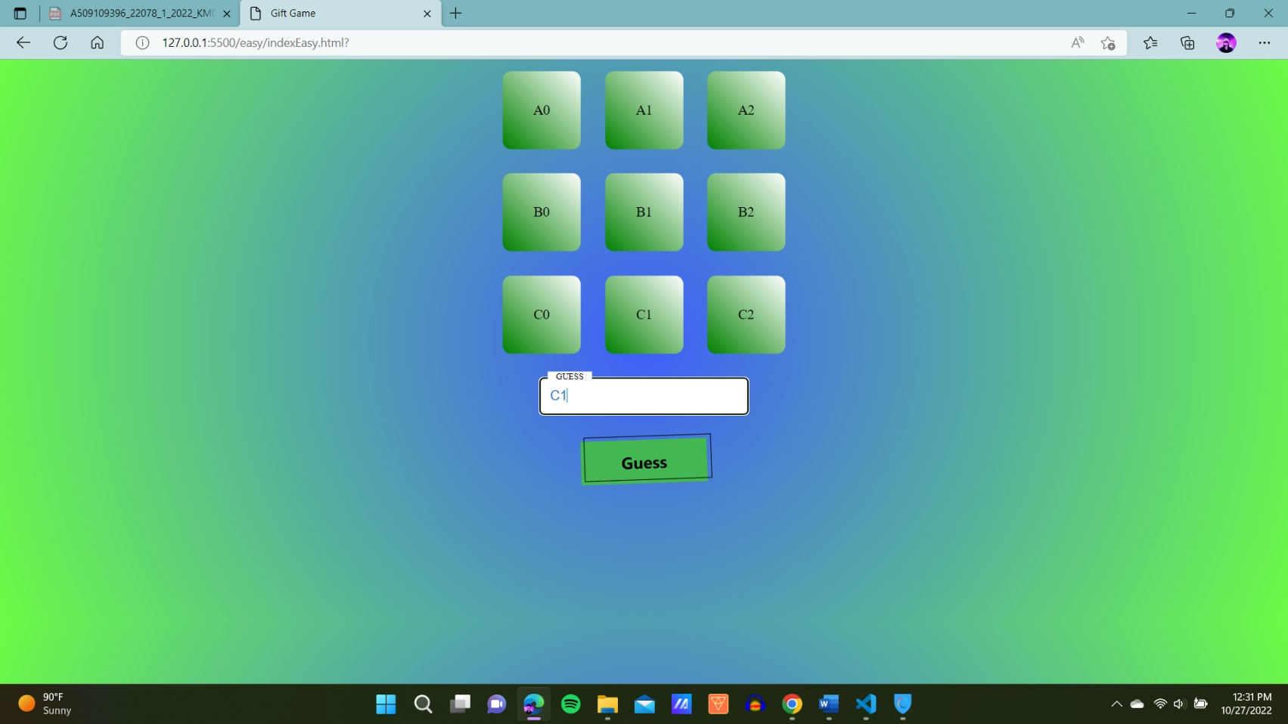Step1 – Enter your guess in the input box.(E.g. C1)

Step2 – Click the Guess button to see what is inside the cards(MISS OR HIT)

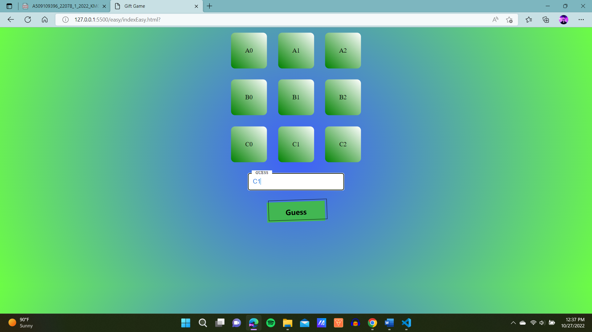

Step3 – The card entered will show its Outcome(E.g. C1 = MISS)

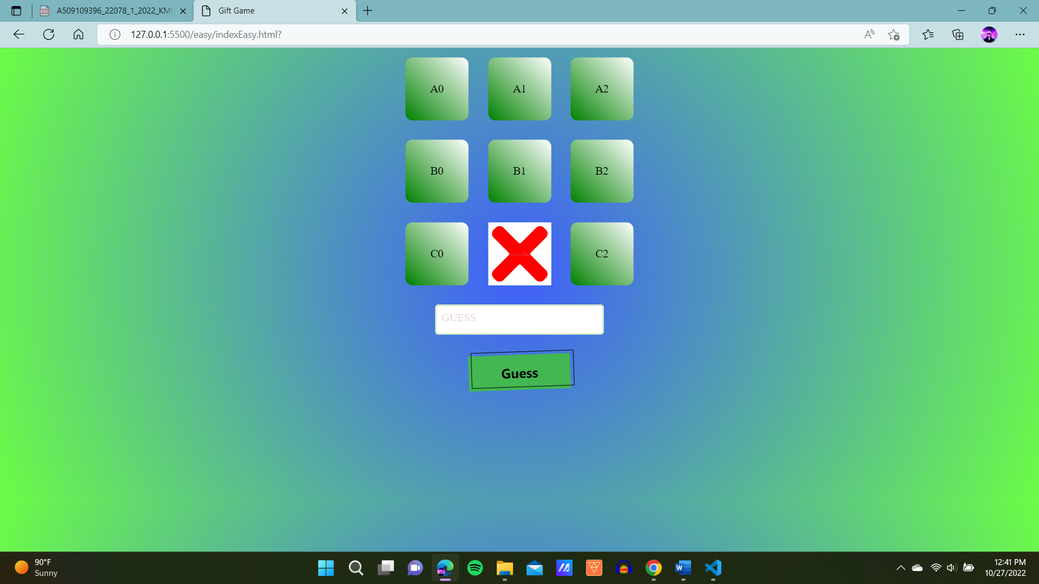

Step4 – Goal is to find 3 Gift in the given Grid

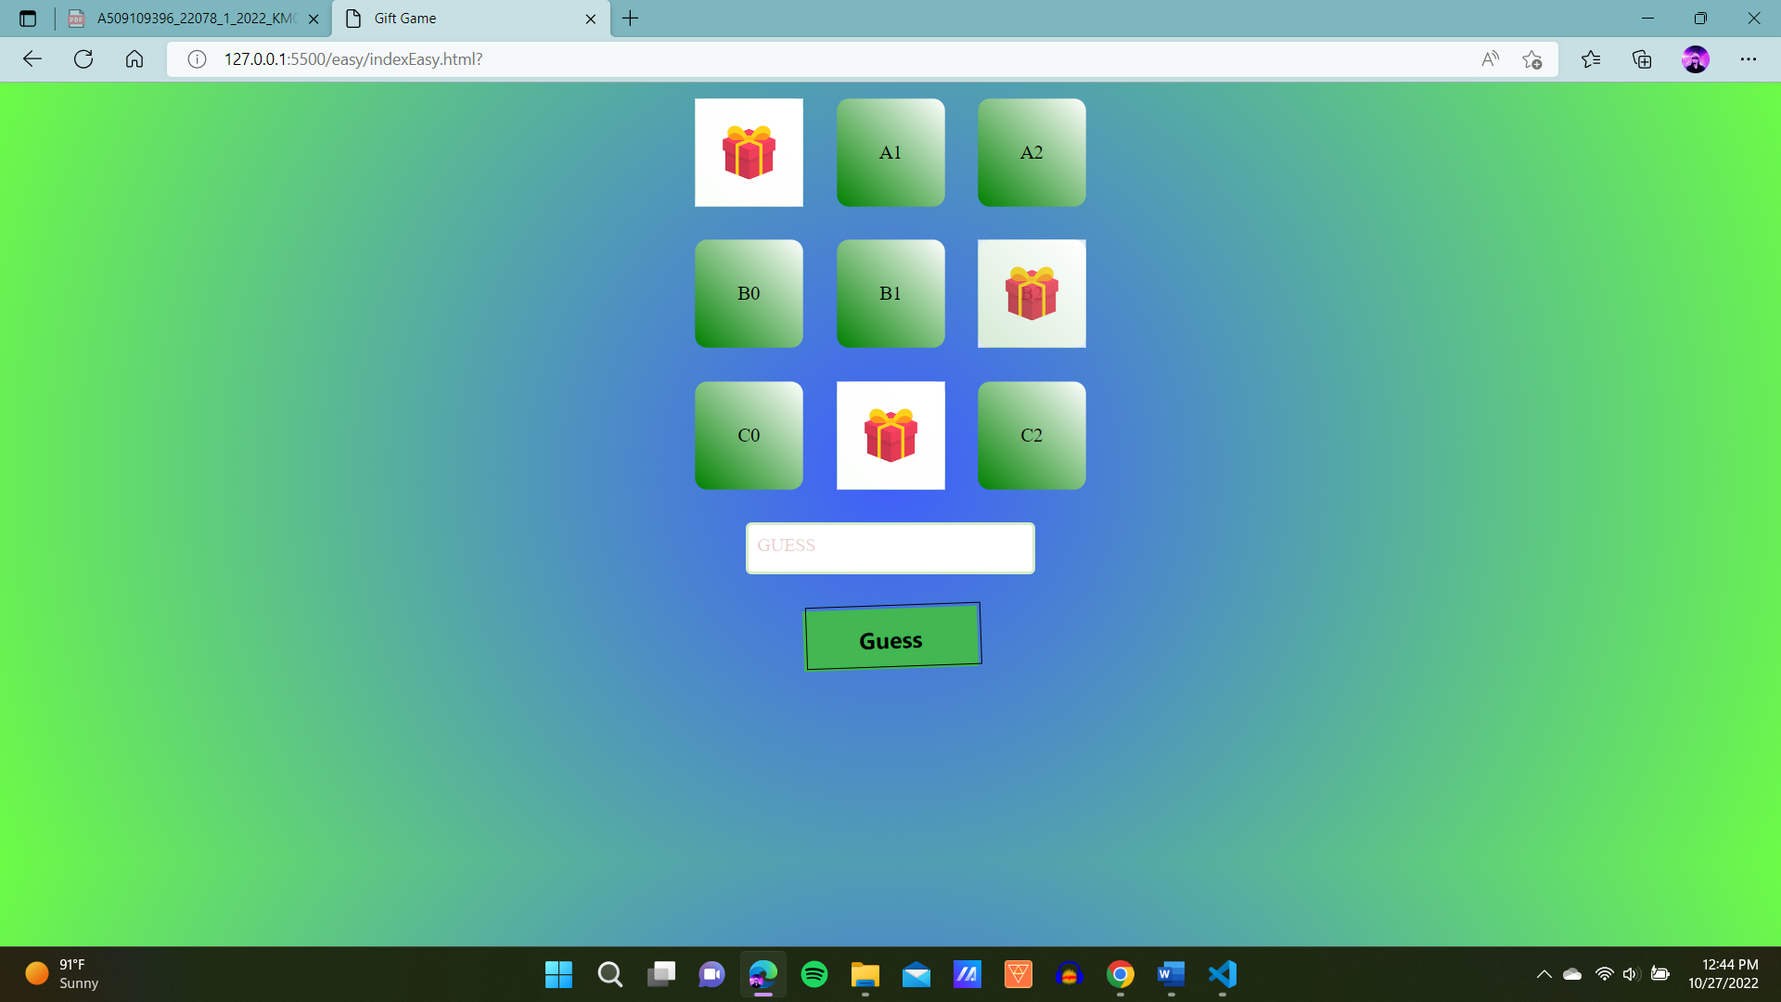

Step5 – Avoid the danger sign (One in the whole grid)

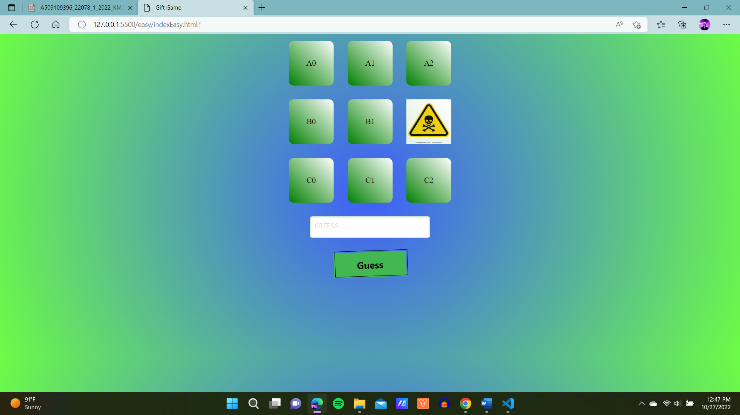

Result and Rating

Result 1 – You WON !!!!!!!!!!

Find all 3 gifts and you win the game

Game will rate you out of 5 stars(less MISS more STARS)

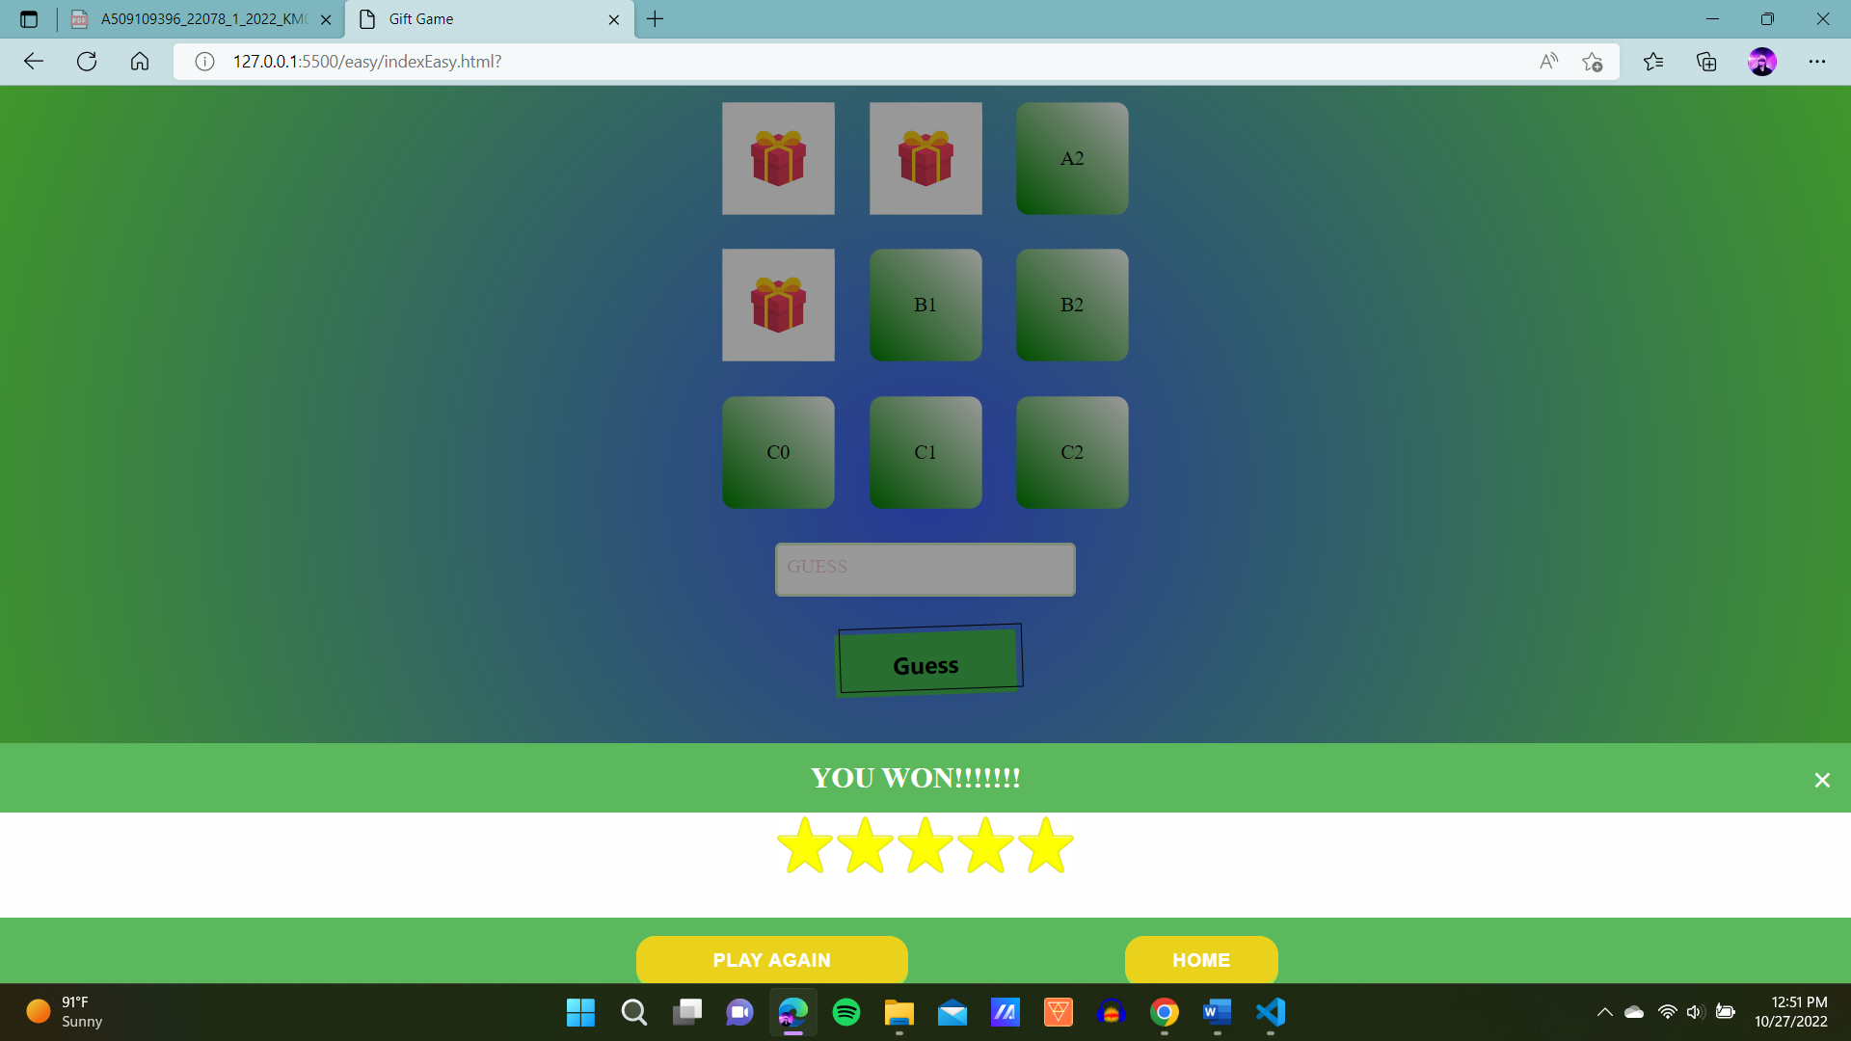

Result 2 – You find danger You LOSE!!!!!!!!!!!!!

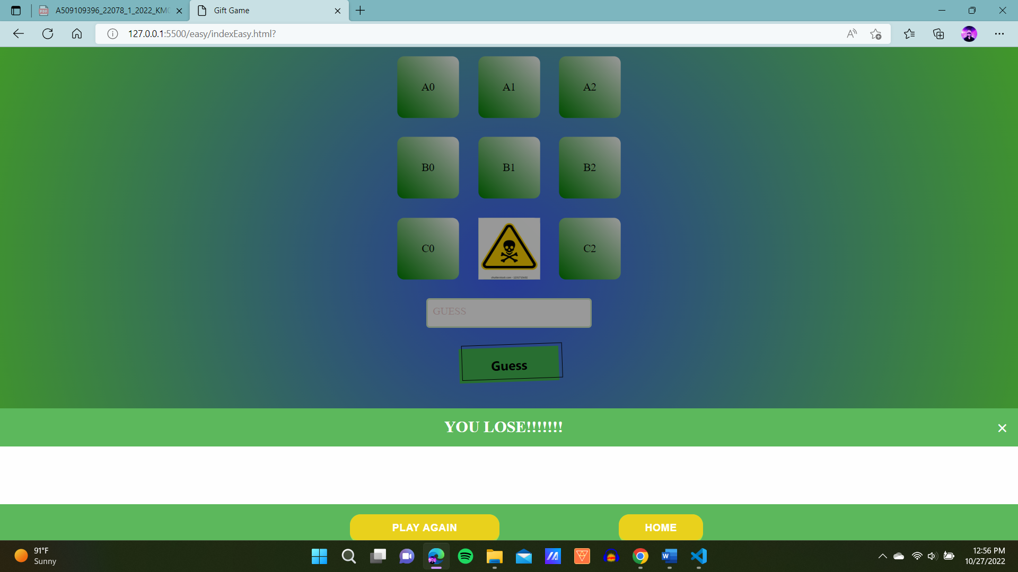

Harder levels

1. Medium level (4X4)



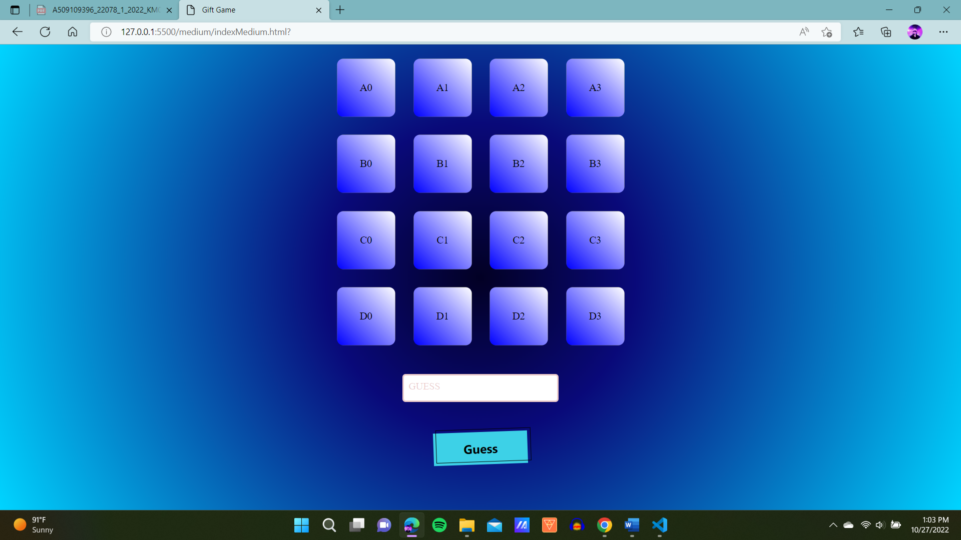

2.HARD LEVEL(6X6)



